软件工程系项目/实验报告

|  |  |  |  |
| --- | --- | --- | --- |
| **姓名** | Ekimovskiy Sasha | **学号** |  |
| **专业班级** |  | **指导教师** |  |
| **课程名称** | Object Oriented System Analysis and Design | | |
| **项目/实验**  **名称** | The Strategy Pattern | | |

一、目的

To apply the Strategy Pattern into the design the Flight Simulation System.

二、过程与步骤

Step1: To analyze the requirement of the project and identify business objects

Step2: To design the class diagram according to the identified business objects based on the understanding of the definition and general class diagram of the Strategy Pattern.

Step3: To create a new package to program according to the class diagram in the Eclipse

Step4: To code a test main class to debug and run the program to verify it.

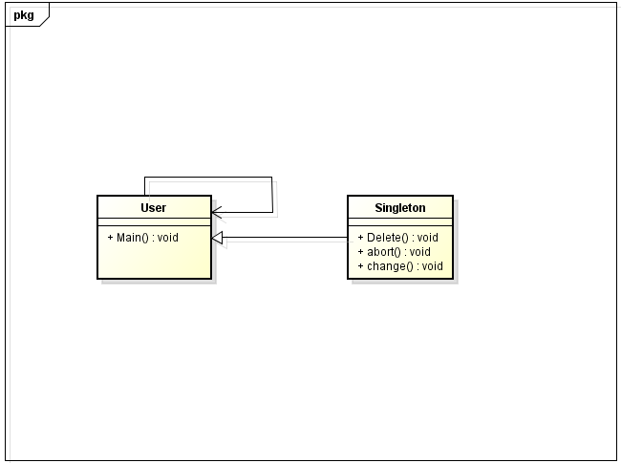

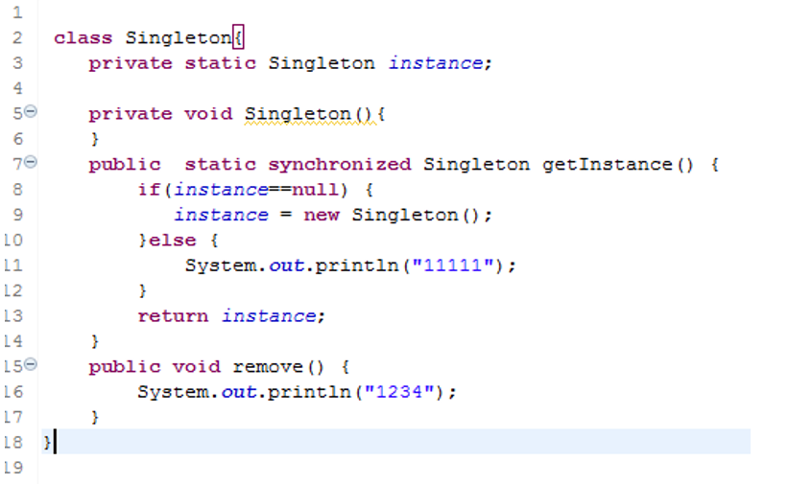

三、结果

评阅成绩：

|  |  |
| --- | --- |
| 成绩 |  |
| 评语 | （可选） |